Physical and Psychological Violence Victim (PPVV) on Adolescent Who Are Dating: Scale Validity and Reliability in Indonesian Version

Abstract
Physical violence is often experienced by intimate couples in places that are considered safe. Psychological violence has not been the main focus of research because it is considered less objective in the assessment. The purpose of the study is to develop a scale of victims of physical and psychological violence in adolescent pairs who are valid and reliable. 294 students in one private university in Yogyakarta have met the criteria as participants. Participants were selected using simple random sampling technique. The scale that was developed was analyzed its validity based on expert judgment, t-value and Standardize Loading Factor (SLF) through Confirmatory Factor Analysis. The reliability of each construct is based on the value of Construct Reliability (CR). The data obtained meets the goodness-of-fit criteria so that it supports Confirmatory Factor Analysis. A total of 37 items have been declared as valid by experts. The results of the Confirmatory Factor Analysis show that the 32-point scale of victims of physical and psychological violence fulfills the criteria of valid and reliable criteria with the values ​​of each t-value in the range 6.41-17.87, SLF in the range 0.38 - 0.85 and CR in the range 0.89 and 0.93.
Keywords: victims of violence, physical and psychological violence, teenagers in intimate pairs, validity and reliability.
Introduction
The dynamics of violence can occur to adolescents. Forms of violence that occur can be physical violence, psychological violence, sexual violence and controlling behavior (World Health Organization, 2012). Violence committed by intimate couples is estimated to have a global prevalence of 30% (World Health Organization, 2013). Intimate partner violence (IPV) can be considered as the most common form of violence experienced by women. In European Union Member States, 22% of women experience physical and / or sexual violence by a partner since the age of 15 years. Prevalence in various countries ranges from 13 to 32% (European Union Agency for Fundamental Rights, 2014). Intimate partner violence is a crime against women committed by people who are known and occur in places that are considered safe such as home or workplace (Lawson, 2012).
Intimate partner violence (IPV) is the most common form of violence experienced by women and is also the most difficult form of violence to recognize (Campbell, 2002; Troisi, 2018). The results of Russell et al. (2014) reported that 78.5% of students had had a partner in the last three months and during that period, they reported high IPV levels in which more than 10% of boys reported forcing partners to have sex, and 39% of girls reported experiencing physical violence by a partner.
In Indonesia, the prevalence of violence in women aged 15-64 years, both unmarried and those who have / are having a partner experienced physical violence by 18.1% and by 33.4% experienced physical and / or sexual violence during life both carried out by spouse and non-spouse (Ministry of Women's Empowerment and Child Protection, 2017). The Annual Note Sheet (CATAHU) in 2018 reported that in private / personal areas, physical violence had the highest percentage of 41% (3,982 cases), while psychological violence was 15% (1,404 cases) (Komnas Perempuan, 2018). The results of Ayu's study, Sofiana and Jayanti (2019) reported that 59.2% of adolescents had committed violence against their partners.
Some studies show that violence by intimate partners (IPV) is more difficult to be recognized from both the perspective of the victim and from the perspective of the community (Herman, 2015; Troisi, 2018). Physical violence is still a violence that often occurs in young adolescent relationships (Viejo, 2014). Psychological violence is not yet the main focus of research as a form of violence because psychological violence is more difficult to evaluate and is less objective than physical violence and other types of violence (Ureña, Romera, Casas, Viejo, & Ortega-Ruiz, 2015). Adolescent girls are more prone to experience psychological violence compared to men (Vagi, O'Malley Olsen, Basile, & Vivolo-Kantor, 2015). Psychological violence is always everywhere and is another form of violence in romantic relationships and is identified as the main source of distress for women who are victims of partner violence.
The effectiveness of adolescents involved in IPV requires valid and specific tools to measure the quantity of adolescent involvement as victims (Troisi, 2018). Screening instruments that have been developed to identify women as victims of IPV such as VITA Scale (Troisi, 2018), IVRAS (Lila, Oliver, Catalá-Miñana, Galiana, & Gracia, 2014), CASR-SF (Ford-Gilboe et al., 2016). The 15-item CAS version has been developed from 12 items developed from the original CAS and 3 items suggested by experts and literature review covering 3 domains, namely physical, sexual and psychological abuse that contain questions about violence experienced for life, current exposure, and the frequency of exposure to violence. The VITA Scale contains items about the specific role of several emotions such as shame, guilt and fear. The VITA Scale aims to assess the intensity of the post-traumatic influence of victims of IPV (Troisi, 2018).
Objectives and research questions
This study aims to develop and validate the scale of victims of violence in adolescents committed by their partners. This scale is focused on the forms of violence experienced, namely physical and psychological violence. The following research questions are proposed for consideration.
- What is the validity of the scale content of victims of physical and psychological violence in adolescent couples?
- How is the validity and reliability of the construct scale of victims of physical and psychological violence in adolescent couples being developed?
METHOD
Participants
The participants in this study were divided into two, namely during the preliminary study and the during the main study. The preliminary study involved 15 respondents (11 women and 4 men) who were selected using convenience sampling techniques. Whereas the main study involved 397 respondents selected using simple random sampling technique at one of the Private Universities in Yogyakarta Indonesia and used the inclusion and exclusion criteria. Inclusion criteria that have been used included: (1) All students who are active in the academic year 2018/2019, (2). Have a partner, (3). Willing to be a respondent. The exclusion criteria that have been used are: (1). Students who are married, (2). Alumni and (3). Do not have a partner. Based on the established criteria, 294 respondents were obtained, 13% were men (37 respondents) and 87% were women (257 respondents). Their ages range from 17 to 25 years with an average age = 20.1 years and SD = 1.4 years. The distribution of respondents consisted of 30% first-level students, 27% second level, 23% third level, 19% fourth level and 2% fifth level.
Scale Development Procedures.
To produce a valid and reliable scale, this study has been divided into two stages, namely content and construct validation. The scale content validation developed was assessed by 5 experts in the field of Psychology and Public Health. Scale construct validation was determined based on responses from 294 respondents who met the inclusion criteria. The experts assess the scale in terms of content: (a). The accuracy of examples of violence, (b). Correspondence of items, (c). Completeness of types of violence, (d). Language suitability, (e). Use of communicative language, (f). Appropriate use of language with the level of development of respondents.
The scale of victims of physical and psychological violence employed Likert 4 scale format. The Likert scale on the questionnaire victims of physical and psychological violence is 0 if they have never experienced violence, 1 if they rarely experience violence, 2 if they often experience violence and 3 if they experience violence very often..
Data Collection Procedures
The main data obtained in this study were collected in 2 ways namely paper and pencil and online. Content validity assessments from experts are administered through validation sheets (paper & pencil). Respondent data for construct validation is administered through a questionnaire formatted via Google form (online). Questionnaires formatted on Google form are items that have been declared valid and have been revised based on advice from experts. Questioners are distributed to prospective respondents through student social media groups.
Data Analysis
Ms. Excel, IBM SPSS 23 and Lisrel 8.80 have been used to analyze the validity and reliability of the scale.
The validity of the content is determined by the Aiken V technique (Aiken, 1985). The validity of each item has been determined by comparing the validity index on the V table against the calculated V value. Experts who have been involved in this study were 5 people and 5 rating numbers, namely Very irrelevant, Less relevant, Quite relevant, Relevant and Very Relevant. Based on the Aiken V table (significance level of 5%), the allowable cut-off value of the content validity index is .80.
In carrying out a factor analysis or more specifically a CFA, a number of requirements must be fulfilled. It includes the adequacy of the sample size and the suitability of the model. The KMO value test and Bartlett Sphericity are used to ensure the adequacy of sample size (Modarresi & Javan, 2018) or to ensure data suitability whether factor analysis can be done or not (Ad'hiya & Laksono, 2018; Gürkan & Kahraman, 2019; Son & Won, 2018). The adequacy or suitability of the model for factor analysis if it fulfills a KMO-MSA value of more than 0.6 (Worthington & Whittaker, 2006) and Bartlett Sphericity is statistically significant or sig. <.05 (Hair, Black, Babin, & Anderson, 2014).
The construct validity of each item is determined based on the t-value and standardized loading factor (SLF) from the Confirmatory Factor Analysis results. Items are declared valid if they meet the t-value> 1.96 and SLF ≥ 0.35 (Hair, Black, Babin, & Anderson, 1998). Referring to these two values, items will be removed and re-analyzed if they do not meet the minimum values ​​(Hidayati, Budiyono, & Sugiman, 2018). The next step is to determine the suitability or suitability of the model through several Goodness-of-Fit indices (Hanifah et al., 2018). Based on the number of observed variables (12 - 30 observed variables) and number of observations (> 250 number of observations), the suitability index in this study refers to the cut-off value of five indices suggested by Hair et al., (2014): χ2 / df , CFI, TLI, SRMR and RMSEA. Table 1 shows the Goodness-of-Fit index standard for a scale model of victims of physical and psychological violence in adolescent pairs.

Table 1. Standard Model index suitability for physical and psychological violence scale
Fit indices | Recommended Values
χ²/df | ≤ 5.00
CFI | ≥ .92
TLI | ≥ .92
SRMR | ≤ .08 with CFI ≥ .92
RMSEA | < .07 with CFI ≥ .92

Formula:
Eq. (1)

After the validity of each item is obtained, the reliability of each construct is determined based on the value of Construct Reliability (CR) (Hair et al., 2014; Wijanto, 2008). The determination of CR value is given by Eq. (1). Model reliability is good if it meets a CR value of ≥ 0.7, but the reliability coefficient of 0.6 to 0.7 can be accepted as long as the indicators of the model construct validity are also good (Hair, Sarstedt, Hopkins, & Kuppelwieser, 2014; Hidayati et al., 2018).
Li represents the standardized loading factor for each construct, i is the item number, n is the number of items and ei represents the error variance.
FINDINGS
Content Validity
Table 2 shows the results of the experts' assessment to determine the Content validity scale of victims of physical and psychological violence in adolescent pairs.

Table 2. Content Validity Scale of Victims of Physical and Psychological Violence
Aiken V | Item 1 | Item 2 | Item 3 | Item 4 | Item 5 | Item 6 | Item 7 | Item 8 | Item 9 | Item 10
PhyVV Scale | 0.8 | 0.8 | 0.8 | 0.8 | 0.8 | 0.8 | 0.9 | 0.8 | 0.9 | 0.8
PsyVV Scale | 0.9 | 0.8 | 0.8 | 0.8 | 0.9 | 0.8 | 0.9 | 0.8 | 0.9 | 0.8

Based on the results of expert validation, the scale of victims of physical and psychological violence consists of 37 items and meets the content validity standard so that it is declared eligible for further analysis (contract validity). The feasibility of the scale of victims of physical and psychological violence is supported by the calculated Aiken V index value greater than the index V table. The magnitude of the calculated V index ranges from 0.8 - 0.9. This indicates that the scale developed can be used for further analysis.

Validity and Reliability
Test the adequacy of the sample size. The analysis shows that the data meet the requirements of adequacy or suitability for factor analysis. This is supported by the KMO MSA value which is greater than the cut-off value and the value of Bartlett's test of Sphericity statistically significant. The results of the analysis of the adequacy of the factor analysis sample size are shown in Table 3.

Table 3. KMO and Bartlett's Test
Kaiser-Meyer-Olkin Measure of Sampling Adequacy. |  | .904
Bartlett's Test of Sphericity | Approx. Chi-Square | 6186.980
 | Df | 528
 | Sig. | .000

Model fit test. After testing the adequacy of the sample size, an analysis of the suitability of the model is then performed to obtain valid and fit items. CFA analysis has been carried out several stages to obtain valid items. The first Confirmatory Factor Analysis was used to analyze 37 items. Even though 37 items already have a t-value> 1.96, four items are removed (PHYVV9, PHYVV12, PHYVV14, PHYVV16) because they have a SLF value lower than the cut off value. The SLF value for each item is shown in Figure 1. The Goodness-of-Fit Index is shown in Table 4 as model 1. Model 1 shows that the model is less fit because the CFI, TLI, SRMR and RSMEA values ​​do not meet the recommended values. Therefore, re-analysis was carried out without including items PHYVV9, PHYVV12, PHYVV14, and PHYVV16. All items (33 items) in the second analysis have fulfilled the cut-off value that is SLF value ≥ 0.35. The SLF value in the second analysis is shown in Figure 2. The Goodness-of-Fit Index is shown in Table 4 as model 2. Model 2 shows the overall model fit because most of the match indices meet the recommended values ​​except the RMSEA value is still quite large. Therefore, in the third analysis the researchers had modified the index as suggested. The results of the modification of the index are shown in Figure 3 and model 3 in table 4. However in the third analysis, the SLF PHYVV11 value has decreased and does not reach the cut-off value so that it is re-analyzed by eliminating PHYVV11 and obtained 32 valid and fit items. Model 4 in table 4 shows the fourth Goodness-of-Fit analysis. It appears that after the second modification, the Goodness-of-Fit Index has increased for the CFI and TLI index and decreased in the index χ2 / df, SRMR and RMSEA.

Table 4. Model fit indices on the scale of physical and psychological violence
Models | Description | χ² | Df | χ²/df | CFI | TLI | SRMR | RMSEA
Model 1 | All item | 2626.05 | 628 | 4.18 | 0.90 | 0.89 | 0.083 | 0.104
Model 2 | Removed item PHYVV9, PHYVV12, PHYVV14, and PHYVV16 | 2261.93 | 494 | 4.58 | 0.91 | 0.90 | 0.084 | 0.111
Model 3 | Index Modification (33 item) | 1129.33 | 428 | 2.64 | 0.96 | 0.94 | 0.069 | 0.075
Model 4 | Index Modification (32 item) with removed PHYVV11 | 1025.80 | 399 | 2.57 | 0.96 | 0.95 | 0.069 | 0.073

Validity & Reliability. Based on the SLF values in Figure 4, the results of the analysis of the CR values were 0.89 and 0.93 for the constructs of physical violence and psychological violence, respectively. The complete validity and reliability values for each construct are shown in Table 5.

Table 5. Validity and Reliability Scale of Victims of Physical and Psychological Violence
Variable | SLF ≥ .35 | Errors | t-value | Reliabilitas CR ≥ .70 | Explanation
Victims of Physical |  |  |  | 0.89 | Reliabel
PHYVV1 | 0.78 | 0.39 | 15.59 | 0.89 | Valid
PHYVV2 | 0.65 | 0.58 | 12.05 | 0.89 | Valid
PHYVV3 | 0.51 | 0.74 | 8.80 | 0.89 | Valid
PHYVV4 | 0.70 | 0.51 | 13.26 | 0.89 | Valid
PHYVV5 | 0.77 | 0.40 | 15.29 | 0.89 | Valid
PHYVV6 | 0.82 | 0.32 | 16.73 | 0.89 | Valid
PHYVV7 | 0.58 | 0.67 | 10.24 | 0.89 | Valid
PHYVV8 | 0.47 | 0.78 | 8.14 | 0.89 | Valid
PHYVV10 | 0.70 | 0.50 | 13.47 | 0.89 | Valid
PHYVV13 | 0.64 | 0.59 | 11.76 | 0.89 | Valid
PHYVV15 | 0.45 | 0.80 | 7.70 | 0.89 | Valid
PHYVV17 | 0.38 | 0.85 | 6.41 | 0.89 | Valid
Victim Of Psychological |  |  |  | 0.93 | Reliabel
PSYVV1 | 0.63 | 0.60 | 11.82 | 0.93 | Valid
PSYVV2 | 0.62 | 0.62 | 11.47 | 0.93 | Valid
PSYVV3 | 0.60 | 0.64 | 11.02 | 0.93 | Valid
PSYVV4 | 0.44 | 0.80 | 7.80 | 0.93 | Valid
PSYVV5 | 0.55 | 0.70 | 9.95 | 0.93 | Valid
PSYVV6 | 0.48 | 0.77 | 8.40 | 0.93 | Valid
PSYVV7 | 0.65 | 0.58 | 12.23 | 0.93 | Valid
PSYVV8 | 0.58 | 0.67 | 10.50 | 0.93 | Valid
PSYVV9 | 0.63 | 0.60 | 11.74 | 0.93 | Valid
PSYVV10 | 0.74 | 0.45 | 14.51 | 0.93 | Valid
PSYVV11 | 0.72 | 0.48 | 13.97 | 0.93 | Valid
PSYVV12 | 0.81 | 0.35 | 16.41 | 0.93 | Valid
PSYVV13 | 0.72 | 0.47 | 14.08 | 0.93 | Valid
PSYVV14 | 0.85 | 0.28 | 17.87 | 0.93 | Valid
PSYVV15 | 0.54 | 0.70 | 9.86 | 0.93 | Valid
PSYVV16 | 0.79 | 0.37 | 15.96 | 0.93 | Valid
PSYVV17 | 0.46 | 0.79 | 8.12 | 0.93 | Valid
PSYVV18 | 0.57 | 0.68 | 10.26 | 0.93 | Valid
PSYVV19 | 0.67 | 0.55 | 12.64 | 0.93 | Valid
PSYVV20 | 0.70 | 0.51 | 13.51 | 0.93 | Valid

DISCUSSION
This study aims to produce a valid and reliable scale of victims of physical and psychological violence both in terms of content (theory) and construct (empirical). The expert assessment results show that the scale of physical violence (17 items) and psychological (20 items) is theoretically valid. This means that all items are in accordance with indicators (Hidayati, Budiyono, & Sugiman, 2018; Joly, Booth, Mittal, & Shaler, 2012). This is supported by the Aiken V index value in the range 0.8 - 0.9. Some suggestions from experts have been used to perfect the editorial sentence on this scale, for example on physical violence (PHYVV10): "My partner dropped me from the vehicle" was changed to "My partner forced me to get off the vehicle in the middle of the trip". In psychological violence (PSYVV4), for example "Couples demand me to have sex" becomes "Couples demand me to have intercourse whenever he wants". It is because the initial statement that was compiled seemed only to occur once.
To carry out the construct validity test, 397 students participated. However, 26% (103 students) were expelled because they did not meet the specified criteria (84 people never dated, 19 people as alumni).
Adequacy of sample size and suitability of the model are requirements that must be fulfilled to carry out a Confirmatory Factor Analysis (CFA). Preliminary requirements test results indicate that the KMO MSA value and the significance value of Bartlett's Test of Sphericity have met the adequacy requirements of the sample size for factor analysis. The KMO MSA value shows the comparison of the distance between the correlation coefficient and the partial correlation coefficient and the significance value of Bartlett's Test of Sphericity shows that overall all correlations in the correlation matrix (Hair et al., 2014). Furthermore, the suitability of the model is determined by looking at the value of the Goodness-of-Fit index. Before reviewing the Goodness-of-Fit index value, the validity of each item must have been fulfilled. In order to obtain valid items empirically, four CFAs have been carried out. The first stage CFA was removed by 4 items on the physical violence scale because its SLF value did not meet the cut-off value. The cut-off value that we use is in accordance with the suggestion of Hair et al., (1998) that is for the 250 sample size, the minimum loading factor is 0.35.
After four items were removed, we re-analyzed and obtained 33 valid items because they had a SLF value greater than the cut-off value. Although in the second stage of the analysis a valid item has been obtained, but most of the Goodness-of-Fit criteria have not yet been fulfilled. Model fit assessments are based on absolute mismatch index (RMSEA or RMR) and relative match index (CFI, TLI, IFI) (Hair et al., 2014; Hanifah et al., 2018). Hair et al., (2014) recommend a TLI and CFI cut-off value of 0.92 (observed variables 12 <m <30 and number of observations> 250) because the value of 0.90 is too low and can lead to acceptance of false models.
To meet the good Good-of-Fit criteria, we continue the third stage of the analysis, which is to modify the index according to the suggestions displayed in the analysis output. There are two choices displayed in the output of the analysis: First, add the path between the latent variable and the observation variable. Second, add covariance between two errors. We did not implement the first suggestion because it did not have a strong theoretical basis to support the suggestion. We follow the second suggestion of adding covariance between two errors in one latent variable (Hair, et al., 2014; Hidayati et al., 2018; Wijanto, 2008). This is done to reduce the value of Chi-Square. However, after the third phase of analysis, PHYVV11 was found to be invalid so it had to be removed and we continued to do the fourth analysis and obtained 32 items that were valid and fit.
Not all fit indices are displayed in this study, three or four match indexes with different types (at least one incrimental index and one absolute index) can provide evidence of adequate model compatibility (Hair et al., 2014). Overall in Table 4 model 4 shows good suitability of the model. This is supported by fit indices that have met recommended values ​​except for RMSEA. Even though RMSEA is less fit, to see the representation of the index of absolute incompatibility (badness of fit) can be replaced by the SRMR value (Hair et al., 2014).
Construct validity is a type of experimental validity that shows the level of accuracy of a number of items to reflect the theoretical latent construct that was designed (Hair et al., 2014; Mcmillan & Schumacher, 2014). Based on Table 5, the scale of victims of physical and psychological violence can be declared valid and reliable. This is supported by SLF values ​​in the range 0.38 - 0.82 (physical violence victims scale) and 0.44 - 0.85 (psychological violence victims scale), CR values ​​0.89 (physical violence victims scale) and 0.93 (psychological violence victims scale). Construct Reliability (CR) shows that the same latent construct has been consistently represented at all steps (Hair et al., 2014).

CONCLUSION
The scale of victims of physical and psychological illiteracy in adolescent couples in the Indonesian version has shown good validity and is acceptable theoretically and empirically (construct). The reliability indicates that the same latent construct has been consistently represented in all steps, thus supporting its role in screening of adolescent in pairs whether experiencing victims of physical and psychological violence.

REFERENCES
Ad’hiya, E., & Laksono, E. W. (2018). Development and Validation of an Integrated Assessment Instrument to Assess Students’ Analytical Thinking Skills in Chemical Literacy. International Journal of Instruction, 11(4), 241–256. https://doi.org/10.12973/iji.2018.11416a
Aiken, L. R. (1985). Three coefficients for analyzing the reliability and validity of ratings. Educational and Psychological Measurement, 45(1), 131–142. https://doi.org/10.1177/0013164485451012
Ayu, S. M., Sofiana, L., & Jayanti, F. U. (2019). The correlation of teacher’s role, peers, and mass media with the incidence of dating violence in adolescents at SMK Piri 1 Yogyakarta. International Journal Of Community Medicine And Public Health, 6(6), 2325. https://doi.org/10.18203/2394-6040.ijcmph20192292
Campbell, J. C. (2002). Health consequences of intimate partner violence. The Lancet, 359(9314), 1331–1336. https://doi.org/10.1016/S0140-6736(02)08336-8
European Union Agency for Fundamental Rights. (2014). Violence against women : An EU-wide survey. Publications Office of the European Union,. https://doi.org/10.2811/62230
Ford-Gilboe, M., Wathen, C. N., Varcoe, C., MacMillan, H. L., Scott-Storey, K., Mantler, T., … Perrin, N. (2016). Development of a brief measure of intimate partner violence experiences: the Composite Abuse Scale (Revised)—Short Form (CAS R -SF). BMJ Open, 6(12), e012824. https://doi.org/10.1136/bmjopen-2016-012824
Foshee, L., Bauman, & Foshee. (2006). Safe Dates—Psychological Abuse Perpetration. In Measuring Intimate Partner Violence Victimization and Perpetration: A Compendium of Assessment Tools is a publication of the National Center for Injury Prevention and Control of the Centers for Disease Control and Prevention. https://doi.org/10.1192/bjp.112.483.211-a
Gürkan, G., & Kahraman, S. (2019). Development of an Attitude Scale To Measure Attitudes Towards Organ Transplantation and Donation of Preservice Teachers. Journal of Baltic Science Education, 17(6), 1005–1016. https://doi.org/10.33225/jbse/18.17.1005
Hair, J. F., Black, W. C., Babin, B. J., & Anderson, R. E. (1998). Multivariate Data Analysis (5th ed). London: Prentice-Hall.
Hair, J. F., Black, W. C., Babin, B. J., & Anderson, R. E. (2014). Multivariate Data Analysis (7th ed). British: Pearson Education Limited.
Hair, J. F., Sarstedt, M., Hopkins, L., & Kuppelwieser, V. G. (2014). Partial least squares structural equation modeling (PLS-SEM): An emerging tool in business research. European Business Review, 26(2), 106–121. https://doi.org/10.1108/EBR-10-2013-0128
Hanifah, M., Mohmadisa, Hashim, Nasir, Nayan, Yazid, … Norkhaidi. (2018). A Confirmatory Factor Analysis of Malaysian Primary School Students’ Energy Saving Practices. Journal of TURKISH SCIENCE EDUCATION, 15(3), 51–63. https://doi.org/10.12973/tused.10237a
Herman, J. (2015). Trauma and Recovery: The Aftermath of Violence from Domestic Abuse to Political Terror. Bible through the Lens of Trauma. New York. https://doi.org/10.2307/j.ctt1h1htfd.13
Hidayati, K., Budiyono, B., & Sugiman, S. (2018). Development and Validation of Student’s Responsibility Scale on Mathematics Learning Using Subject Scaling Model. International Journal of Instruction, 11(4), 499–512. https://doi.org/10.12973/iji.2018.11431a
Hudson, W, W. (2006). Partner Abuse Scale—Non-physical (PASNP). In Measuring Intimate Partner Violence Victimization and Perpetration: A Compendium of Assessment Tools is a publication of the National Center for Injury Prevention and Control of the Centers for Disease Control and Prevention. Centers. Atlanta, Georgia: CDC. https://doi.org/10.1192/bjp.111.479.1009-a
Kementerian Pemberdayaan Permeuan dan Perlindungan Anak. (2017). Statistik Gender Tematik; Mengakhiri Kekerasan Terhadap Perempuan dan Anak di Indonesia. Jakarta: Kementerian Pemberdayaan Perempuan dan Anak.
Komnas Perempuan. (2018). Lembar Fakta dan Poin Kunci Catatan Tahunan (CATAHU) Komnas Perempuan Tahun 2018. Komnas Perempuan.
Lawson, J. (2012). Sociological Theories of Intimate Partner Violence. Journal of Human Behavior in the Social Environment, 22(5), 572–590. https://doi.org/10.1080/10911359.2011.598748
Lila, M., Oliver, A., Catalá-Miñana, A., Galiana, L., & Gracia, E. (2014). The Intimate Partner Violence Responsibility Attribution Scale (IPVRAS). The European Journal of Psychology Applied to Legal Context, 6(1), 29–36. https://doi.org/10.5093/ejpalc2014a4
Mcmillan, J., & Schumacher, S. (2014). Research in Education Evidence-Based Inquiry (7th ed). England: Pearson Education Limited.
Modarresi, G., & Javan, E. (2018). Construction and Validation of Foreign Language Learners’ Dropout Questionnaire. International Journal of Instruction, 11(4), 425–444. https://doi.org/10.12973/iji.2018.11427a
Russell, M., Cupp, P. K., Jewkes, R. K., Gevers, A., Mathews, C., LeFleur-Bellerose, C., & Small, J. (2014). Intimate Partner Violence Among Adolescents in Cape Town, South Africa. Prevention Science, 15(3), 283–295. https://doi.org/10.1007/s11121-013-0405-7
Shepard, M, F., & Campbell, J. . (2006). Psychological/ Emotional Victimization Scales: Partner Abuse Scale—Physical (PASPH). In Measuring Intimate Partner Violence Victimization and Perpetration: A Compendium of Assessment Tools is a publication of the National Center for Injury Prevention and Control of the Centers for Disease Control and Prevention. Atlanta, Goergia. https://doi.org/10.1192/bjp.111.479.1009-a
Son, Y. J., & Won, M. H. (2018). Psychometric Validation of the Korean Version of the 9-Item European Heart Failure Self-Care Behaviour Scale. Evaluation and the Health Professions, 1–18. https://doi.org/10.1177/0163278718817946
Troisi, G. (2018). Measuring Intimate Partner Violence and Traumatic Affect: Development of VITA, an Italian Scale. Frontiers in Psychology, 9(JUL), 1–14. https://doi.org/10.3389/fpsyg.2018.01282
Ureña, J., Romera, E. M., Casas, J. A., Viejo, C., & Ortega-Ruiz, R. (2015). Psichometrics properties of Psychological Dating Violence Questionnaire: A study with young couples. International Journal of Clinical and Health Psychology, 15(1), 52–60. https://doi.org/10.1016/j.ijchp.2014.07.002
Vagi, K. J., O’Malley Olsen, E., Basile, K. C., & Vivolo-Kantor, A. M. (2015). Teen Dating Violence (Physical and Sexual) Among US High School Students. JAMA Pediatrics, 169(5), 474–482. https://doi.org/10.1001/jamapediatrics.2014.3577
Viejo, C. (2014). Physical dating violence: towards a comprehensible view of the phenomenon / Violencia física en las relaciones sentimentales adolescentes: hacia la comprensión del fenómeno. Infancia y Aprendizaje, 37(4), 785–815. https://doi.org/10.1080/02103702.2014.977110
Wijanto, setyo H. (2008). Struktural Equation Modelling dengan Lisrel 8.8:Konsep dan Tutorial (1st ed). Yogyakarta: Graha Ilmu.
World Health Organization. (2012). Understanding and addressing violence against women. WHO. https://doi.org/10.1002/ar.1092350414
World Health Organization. (2013). Responding to intimate partner violence and sexual violence against women. Geneva.
Worthington, R. L., & Whittaker, T. A. (2006). Scale Development Research: A Content Analysis and Recommendations for Best Practices. The Counseling Psychologist, 34(6), 806–838. https://doi.org/10.1177/0011000006288127

Apendix
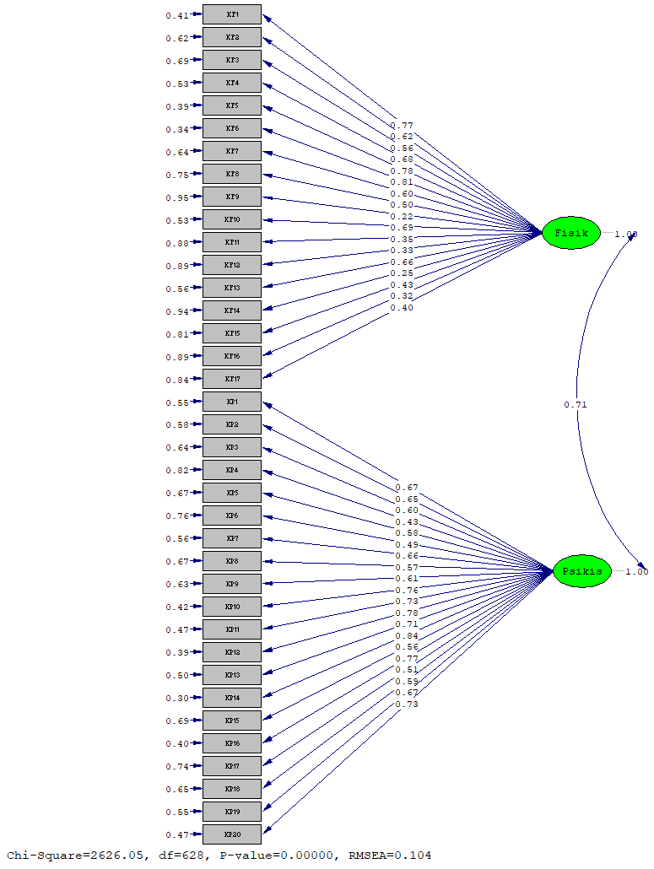
Figure 1. CFA model 1

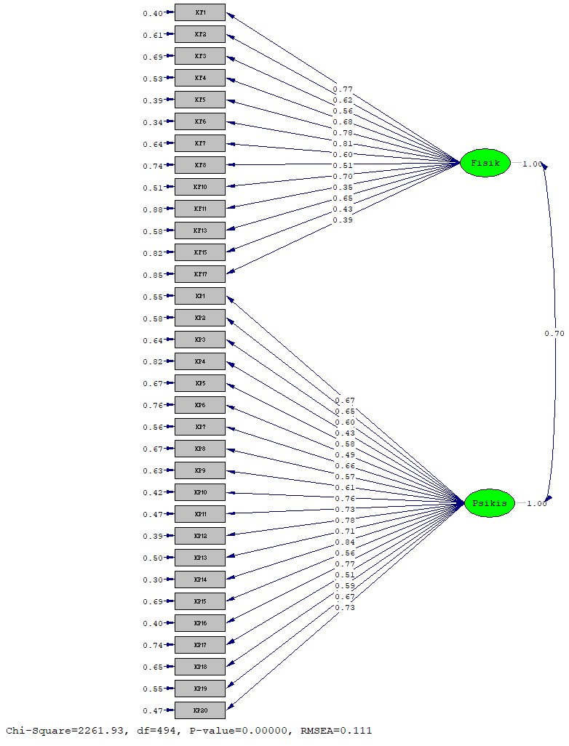
Figure 2. CFA model 2
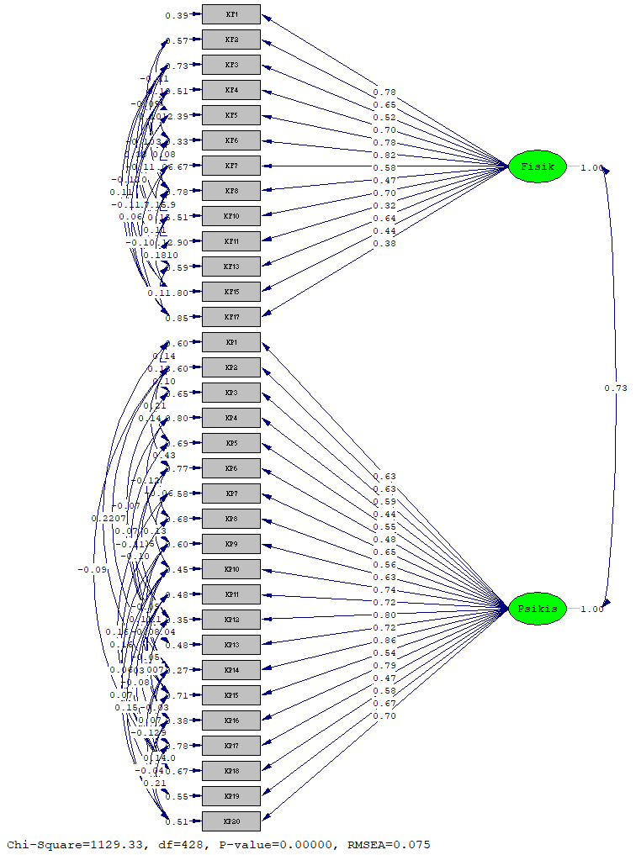
Figure 3. CFA model 3
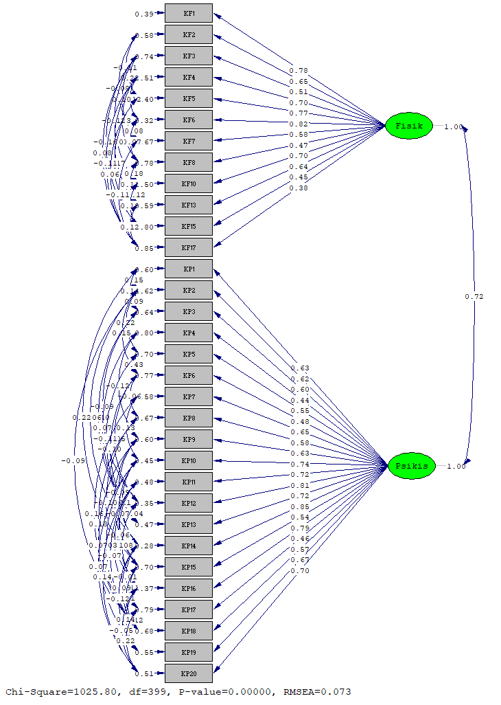
Figure 4. CFA model 4

